Temp Tables and Variable Tables

1. **Local temp table**

1. **Global Temp Variable**

1. **Table Variable**

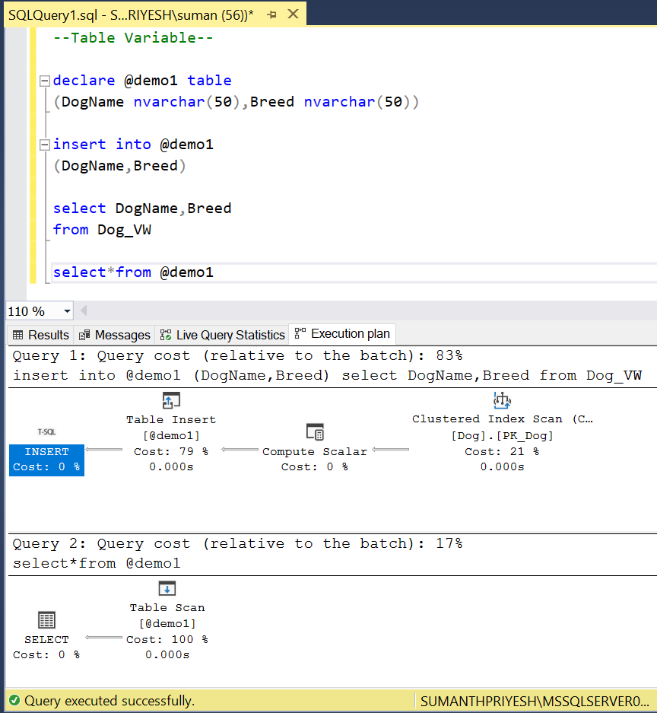

**Compare: Temp local, global, Variable, View**

****